This article contains images of summit register entries from three museums in Canada. Most of the images are from the Whyte Museum of the Canadian Rockies, First Ascent and Summit Note Collection, located in Banff, Alberta.

There is also a small collection of summit register entries from the North Vancouver Museum and Archives, for climbs in Cascade Range of British Columbia.

There is also a single summit register entry from Royal BC Museum and Archives, located in Victoria, British Columbia.

**Mt Waddington, Southwest Face in August 1942**

In late June 1942 when the Beckey brothers and Erik Larson left Seattle for their attempt on Mt Waddington, they stopped in Vancouver, BC to visit Don and Phyllis Munday. Fred and Helmy interrogated Don and Phyllis for all the information they could get about Mystery Mountain.

In July 1942 the Munday’s left for their climb of Mt Queen Bess, located east of Mt Waddington, with Henry Hall. On July 20th at 8,000 feet on Mt Queen Bess the group got their first views of Mt Waddington during their trip. As they looked westward, Don and Phyllis began to fret about the two young Beckey brothers. They had no way of knowing that Fred and Helmy Beckey would make the second ascent of Waddington’s summit in early August.

*****

The first ascent entry by Fritz Wiessner and Bill House, is written vertically in the bottom right hand corner on the left-hand page.

Fred and Helmy Beckey signed the register they found in a match can. Here is a transcription of their entry.

2nd Ascent of

Mt. Waddington

(19) Fred Beckey Seattle

(17) yrs Helmy Beckey Mountaineers

old

tomorrow August 6, 1942

8:30 P.M.

Left at base of mtn at

4 A.M. followed

“Weissners Route”. Made

Upper half in 4 ½ hrs, but

Lower half slowed us up.

Hope we live thru the

night.

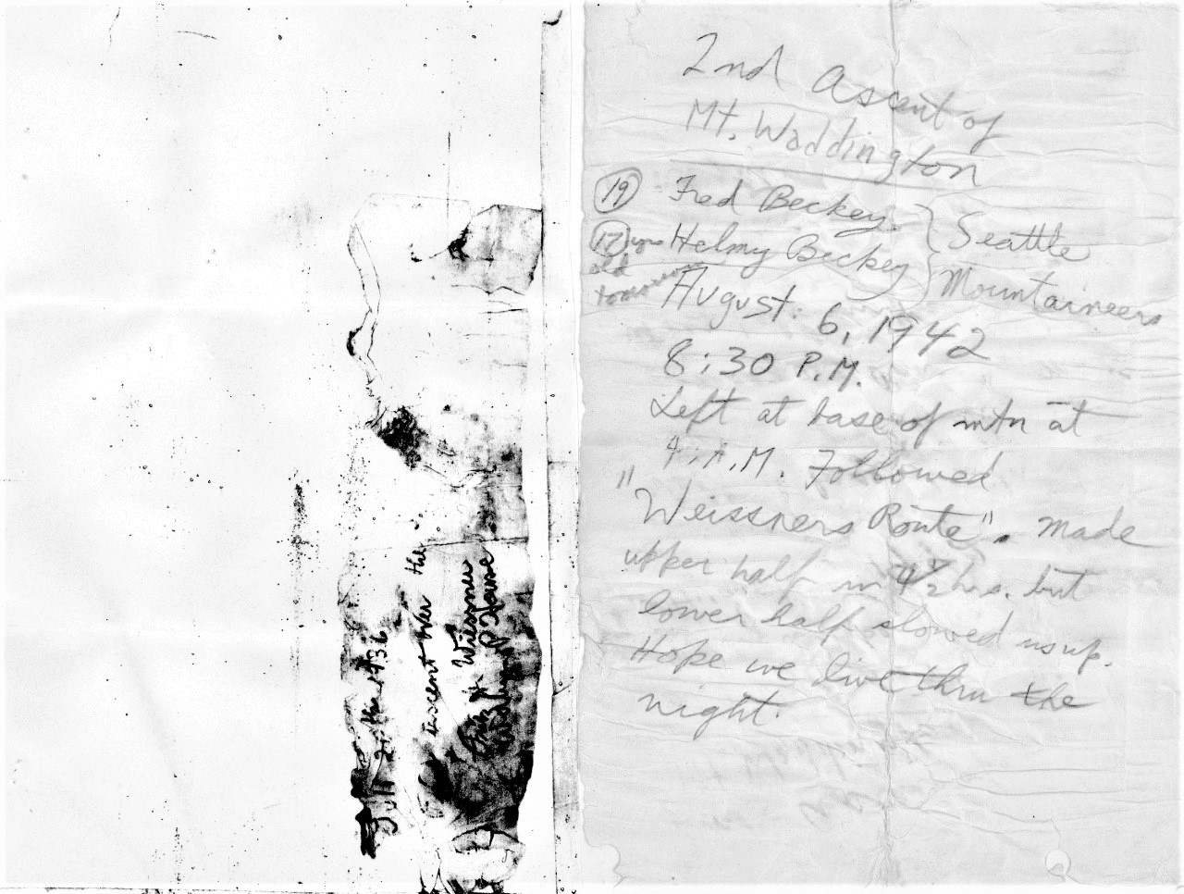

Image I-61544 courtesy of the Royal BC Museum and Archives.

Below is a rotated and cropped image of the first ascent entry by Fritz Wiessner and Bill House. Partial transcription included.

July 21st, 1936

First ascent over the

????

Fritz H. Wiessner

William P. House

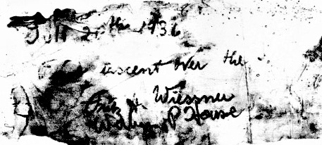

Image I-61544 courtesy of the Royal BC Museum and Archives.

The Beckey brothers would bivouc on a ledge 150 feet beneath the summit, inside their tent sacks, anchored to the mountain by pitons. On the cautious descent the next day, Helmy suffered a nasty cut to his knee by rockfall. Fred attempted to stop the persistant bleeding of Helmy’s wound. They ended up spending a second uncomfortable, and in Helmy’s case, painful night. Helmy completed the descent in extreme pain with Fred the next day. Helmy rested and recovered from his wound for a couple of days , then the brothers began their exit, arriving at salt water on August 16th.

News reached the outside world of their ascent of Mt Waddington on August 21st, in time to make the the evening edition of the *Seattle Times*, with the sensational headline “2 Seattleiltes Escape Death In Avalanche on Canadian Mountain.” It was extraordinary that this article was on the front page of the newspaper, above the fold. All the other articles on page 1 of the *Seattle Times* were about World War II, which was not going well for the United States and its allies in the summer of 1942.

The following day the *Seattle Post Intelligencer* and *Seattle Times* both had lengthy articles.

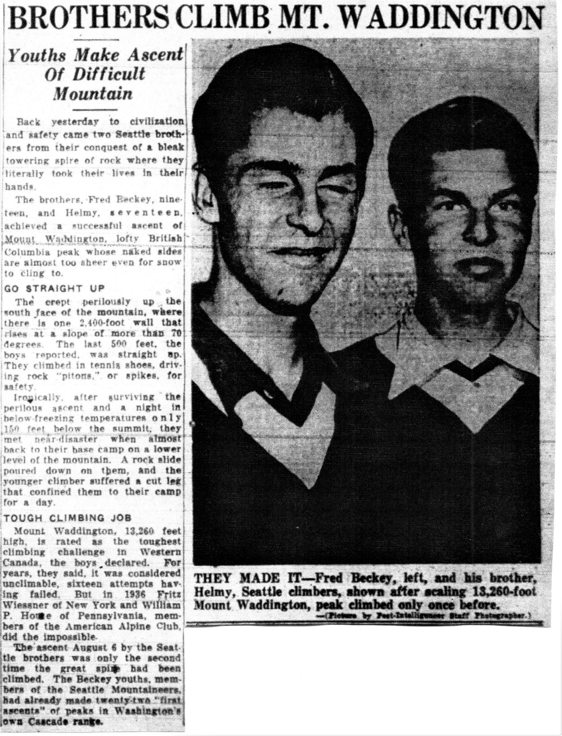

*Seattle Post Intelligencer.* August 22, 1942, 11.

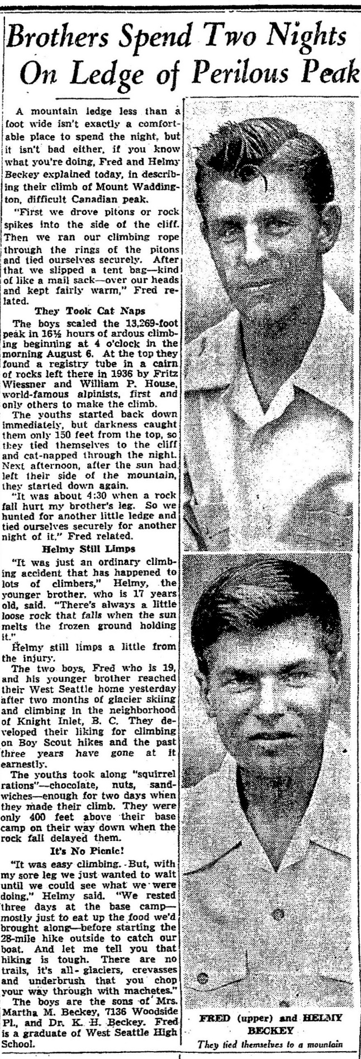

*Seattle Times.* August 22, 1942, 4.

Fred Beckey would have a second encounter with Don Munday under tragic circumstances, in the Waddington Range during the summer of 1947. Fred Beckey joined a large group of climbers from the Harvard Mountaineering Club for a two-month expedition into the Waddington Range. On July 22, 1947, Charles Shiverick died in an avalanche during an attempt on Serra II. The other climbers Leonard Winchester, Harry King and Fred Beckey barely survived the avalanche but suffered injuries, some serious. In Beckey’s case several broken ribs and King a dislocated shoulder.

The leader of the group William Putnam, along with David Michaels made it out to Tatla Lake and news of the tragedy soon reached the outside world. See below for two early newspaper accounts of the accident. The first article incorrectly identifies that the tragedy occurred on Mt Waddington and erroneously states that the group will continue their attempt on Mt Waddington – which was never on the group’s agenda. In the second article, the group’s leader William Putnam speculates that a minor earthquake triggered the avalanche. This was never stated as a cause in the trip reports written in the *American Alpine Journal* and *Canadian Alpine Journal.*

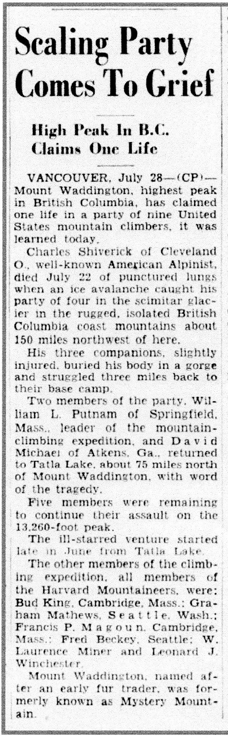 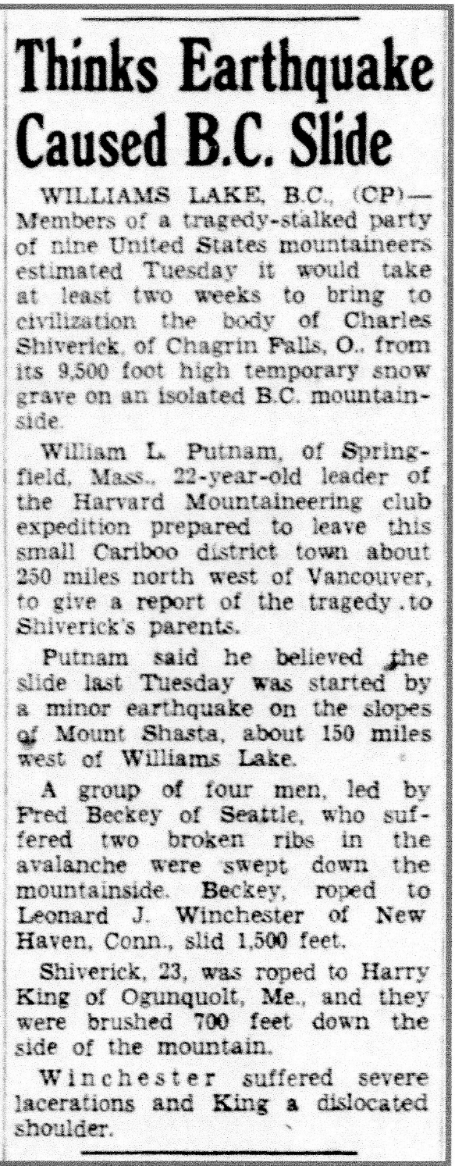

*Ottawa Citizen.* July 28, 1947, 1. *Edmonton Journal.* July 30, 1947, 18.

Charles Shiverick’s wife traveled to Vancouver and wanted to have her husband’s body evacuated. Because of Don Munday’s knowledge of the Waddington Range he was asked to join the evacuation group.

On August 17th Don Munday and Neal Carter were flown into the area by helicopter, with the idea of somehow evacuating Charles Shiverick’s body located at over 10,000 feet on a rock ledge of the steep south slope of Serra II. Beckey led Munday, Carter and two members of the expedition to the site of Shiverick’s body on August 18th. After discussing various evacuation options, it was decided that an evacuation was unfeasible. Instead the body was interned nearby in the snow. Later a mountain and a glacier, some 6 miles northeast of Serra II, were named in the memory of Shiverick.

This would be the last time that Don Munday visited the Waddington Range, the area he and his wife had so thoroughly explored, photographed and mapped. He would die in 1950, while Phyllis would live another 40 years before passing away at age 95.

**Bugaboo Spire, East Ridge in July 1959**

This entry is for a climb of Bugaboo Spire on July 24, 1959, done in 4½ hours. Its was the only climb that Beckey completed in the Bugaboos Area which was not a new route that summer. His climbing partner was the outstanding climber from Calgary, Alberta, Brian Greenwood, who made the entry.

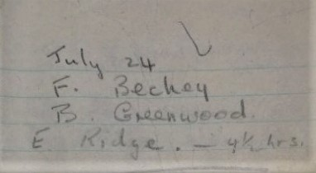

Image M235/accn 5200-20 copied from the Whyte Museum of The Canadian Rockies, Banff, Alberta.

**Mt Sir Donald, Direct North Face in August 1961**

Here is a summit register entry for a climb up the 2,500 ft North Face of Mt Sir Donald in the Selkirk Mountains, with the great Yvon Chouinard. They completed this new route on the heels of climbing the North Face-Direct of Mt Edith Cavell with Dan Doody on July 21st, which was also a new route.

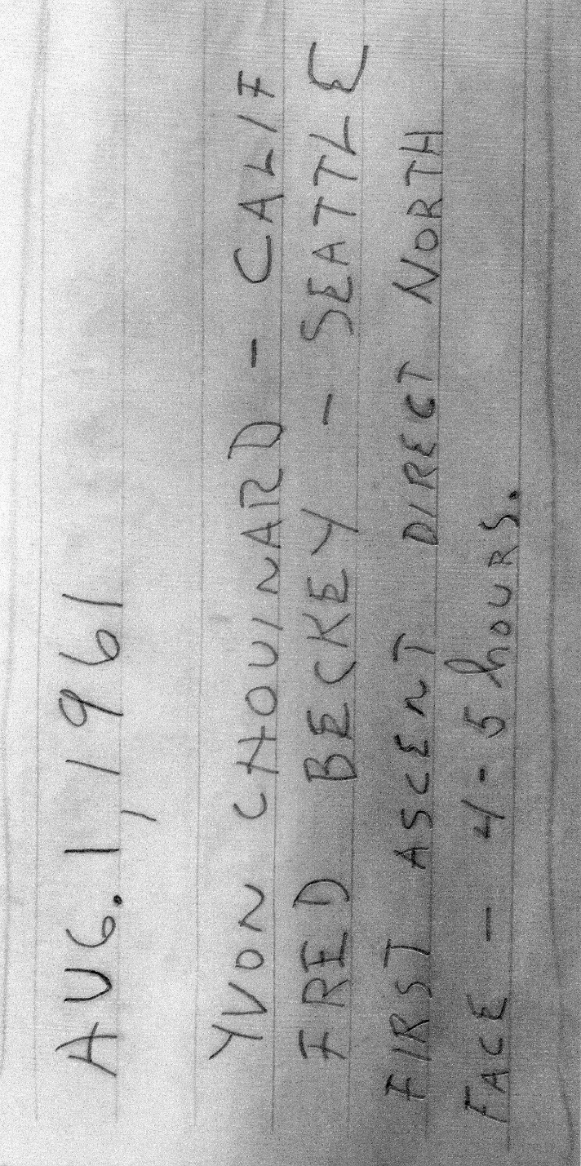

Image M235/accn 5200-5 copied from the Whyte Museum of The Canadian Rockies, Banff, Alberta.

Below is an article from the *Edmonton Journal* for the climb of Mt Edith Cavell on July 21st.

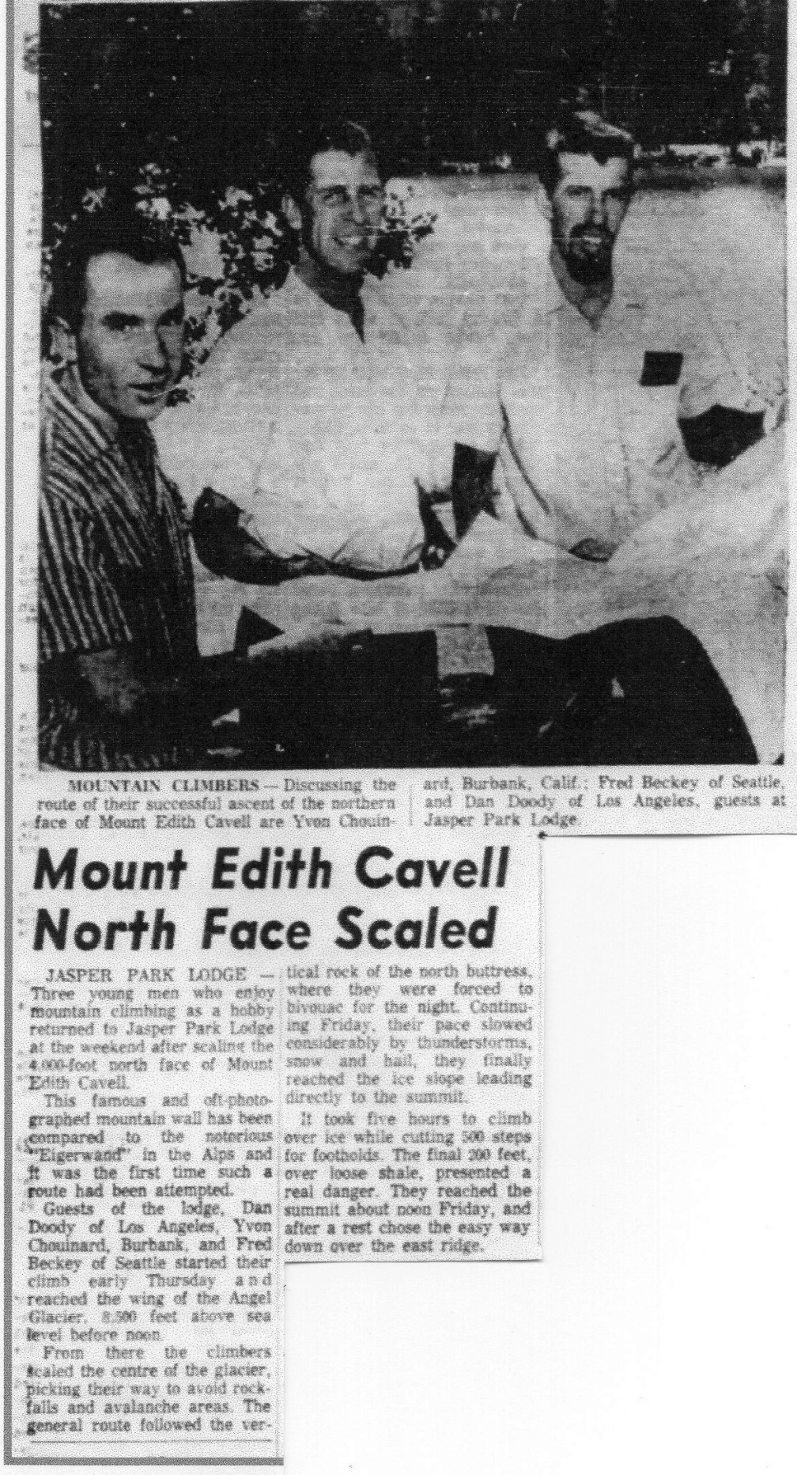

*Edmonton Journal.* July 24, 1961, 20.

**Mt Louis, West Face in July 1962**

This summit register entry is for the climb of Mt Louis in the Sawback Range, which is located six or seven miles northwest of Banff. Either John or Ila Rupley made the entry, because Fred’s last name is misspelled. John Rupley was one of Beckey’s most frequent climbing partners, doing numerous climbs together between 1956 and 1985. Twenty-two were new routes, of which this route up the West Face is one.

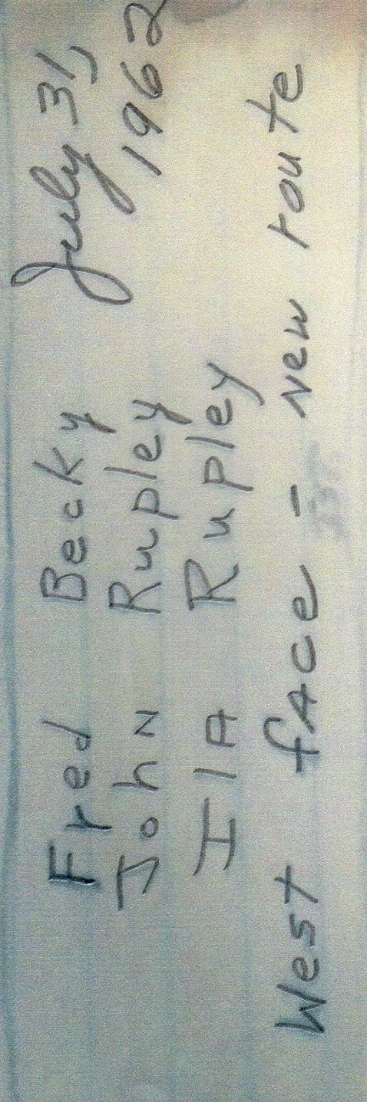

Image M235/accn 5200-3299 copied from the Whyte Museum of The Canadian Rockies, Banff, Alberta.

**Bugaboo Spire, Kain Route in August 1967**

This entry is for the climb of the classic Kain Route or South Ridge of Bugaboo Spire, with one of California’s premier climbers Galen Rowell.

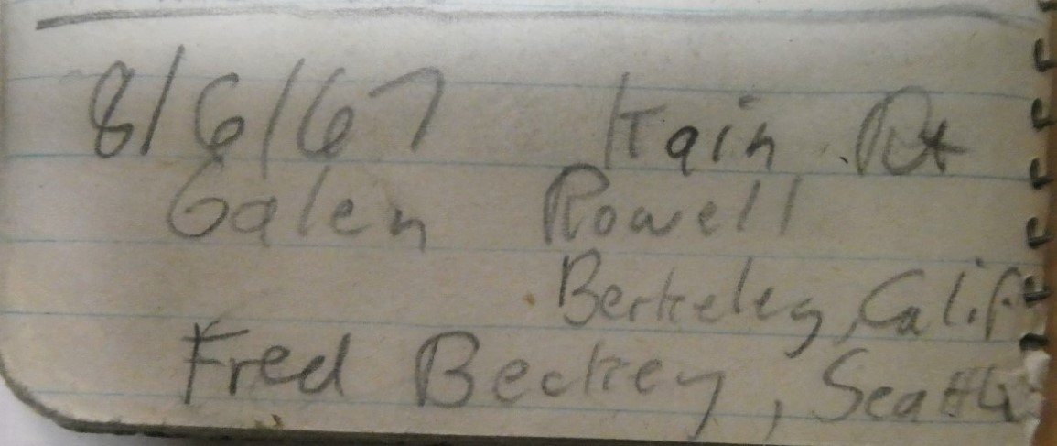

Image M235/accn 5200-20 copied from the Whyte Museum of The Canadian Rockies, Banff, Alberta.

**Mt Bridgland, East Face in August 1973**

The following is a summit register entry for the climb of Mt Bridgland in 1973. The three climbers ascended the East Face, which was a new route. The mountain is part of the Victoria Cross Range, located in Jasper National Park. The reference to the “The Ramparts” at the end of the entry, is to the mountain range of that name located south of Mt Bridgland, where Beckey climbed multiple new routes between 1962 and 1965.

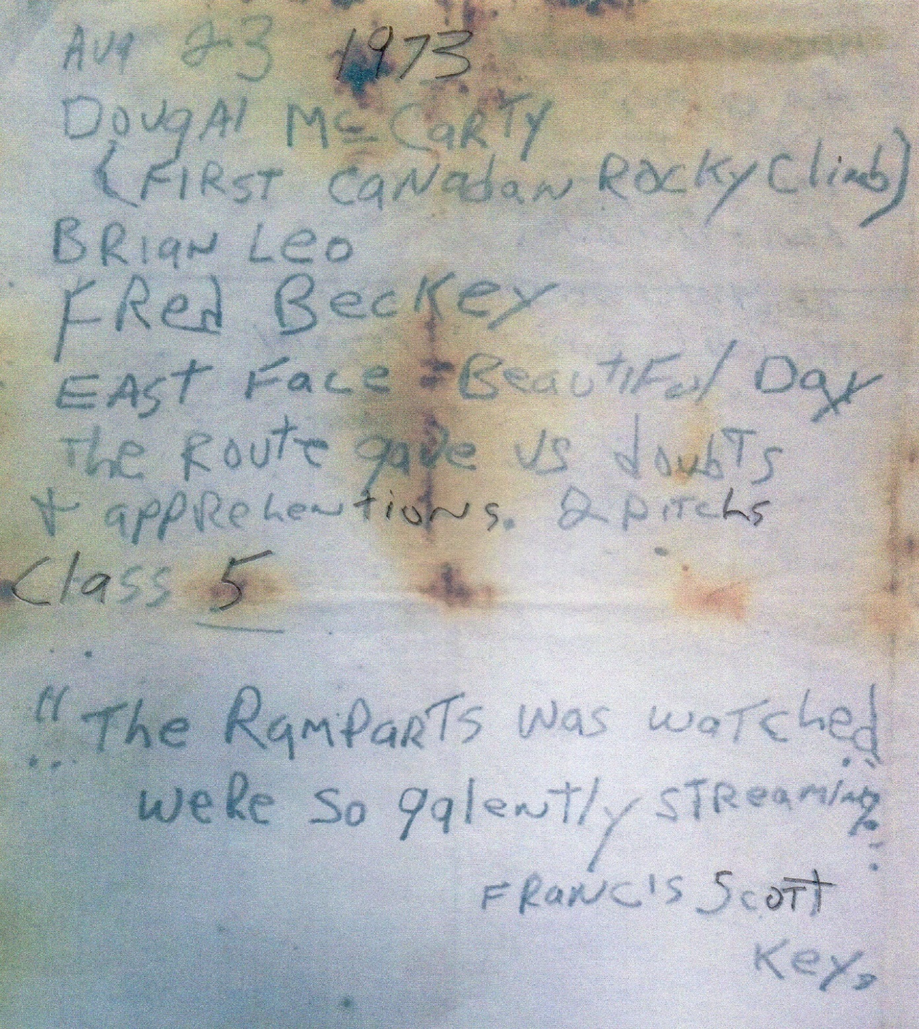

Image M235/accn 5200-5605 copied from the Whyte Museum of The Canadian Rockies, Banff, Alberta.

**Mt Rexford, West Ridge in June 1994**

The next summit register entry was made for a climb of Mt Rexford in the Cascade Range on June 29, 1994. This is the latest summit register entry in Beckey’s climbing career that I have found so far. Fred did not sign the register, because his last name is mis-spelled. Someone in the climbing party adds a note at the bottom of the entry, which I could partially decipher. Something about the next revision of the *Cascade Alpine Guide: Climbing & High Routes*, *Volume 3: Rainy Pass to Fraser River* (or red book), will need to be updated to include a revision for the approach for the climb.

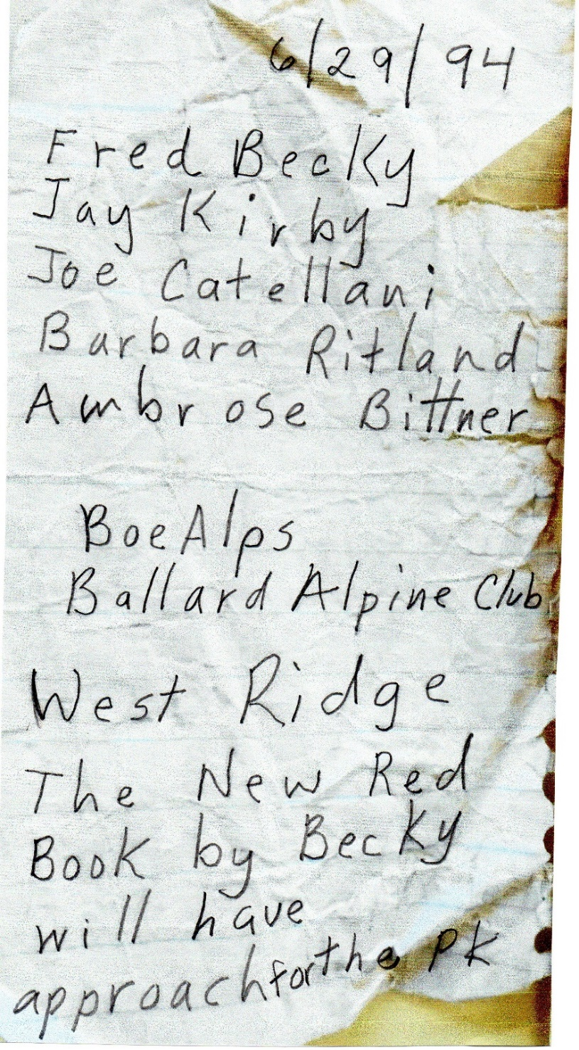

Image “fonds Series 009-Summit registers 1951-2008” copied from North Vancouver Museum and Archives.

**Bonus Material #1: Mt Slesse, Northeast Buttress in 1994 by Dan Cauthorn & Jon Krakauer**

This summit register entry is for a climb of the Northeast Buttress of Mt Slesse by Dan Cauthorn and the well-known climber and writer Jon Krakauer. The entry concludes with the remark that is was “Awesome Line! The final 6-8 pitches are totally killer!”

The two climbers would also pair up to ascent one the most difficult ice routes in the world, the Ferrari Route of Cerro Torre in Patagonia, during January 1992.

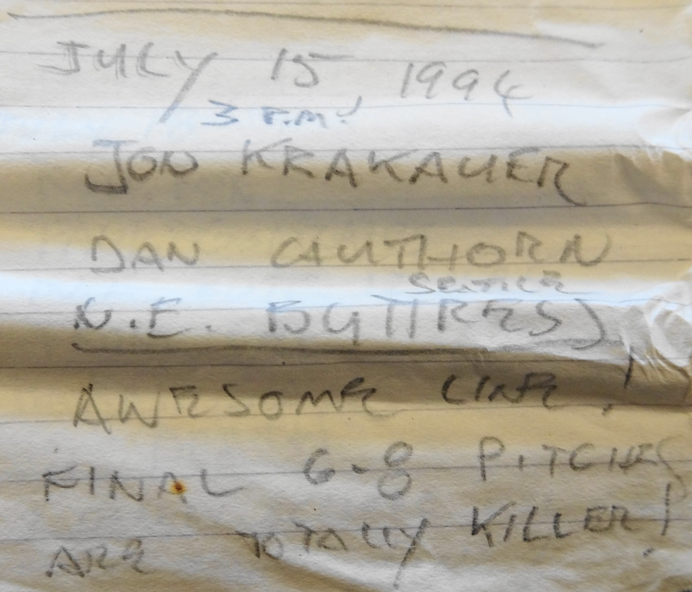

Image “fonds Series 009-Summit Registers 1951-2008” copied from North Vancouver Museum and Archives. Mt Slesse (1989-2003).

**Bonus Material #2: Shelf Mountain in July 1930 by Don and Phyllis Munday**

This summit register entry is for a ski ascent of Shelf Mountain (8,297 ft) in the Waddington Range. The mountain is located about seven miles southwest of Mt Waddington, between the Confederation and Franklin Glaciers.

After exploring and climbing in the Waddington Range between 1926 and 1928, Phyllis and Don Munday took a gap year in 1929 from their post graduate work mountaineering in the Waddington Range. But they put this year to good use by being in the vanguard of the learning the sport of ski-mountaineering, which was just catching on in Vancouver, British Columbia. They felt this skill would increase their speed and expand the distances they could cover on the huge snowfields and glaciers of the Waddington Range.

They put their ski-mountaineering skills to the test when they returned to the Waddington Range in July 1930. From their base camp at Icefall Point on the west side of the Franklin Glacier, they immediately applied their newly honed skills by ascending nearby Mt Redbreast (6,722 ft), on July 17, 1930.

The next day they did a ski ascent of Shelf Mountain, located north of Mt Redbreast.

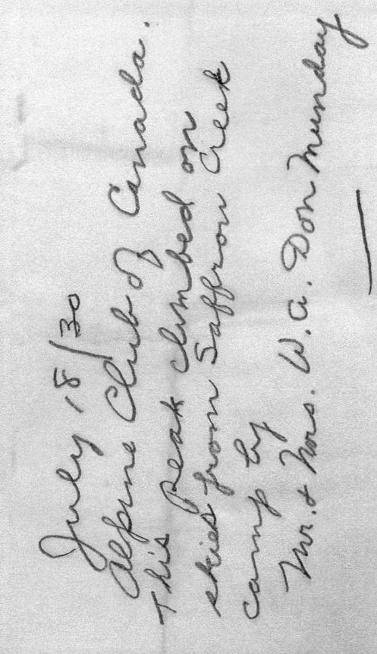

Image M235/accn 7276/20 copied from the Whyte Museum of The Canadian Rockies, Banff, Alberta.

Mt Munday was named in their honor in 1927 and had not been climbed yet. The mountain is located about 3 miles southeast of Mt Waddington and offers spectacular views of the fore mentioned mountain along with Combatant Mountain, Mt Tiedemann, Asperity Mountain and Serra Peaks. The highlight of their 1930 trip was to use their skis to make the first ascent of Mt Munday from the southwest, in a 24-hour push from Icefall Point – approximately a 20-mile round trip.

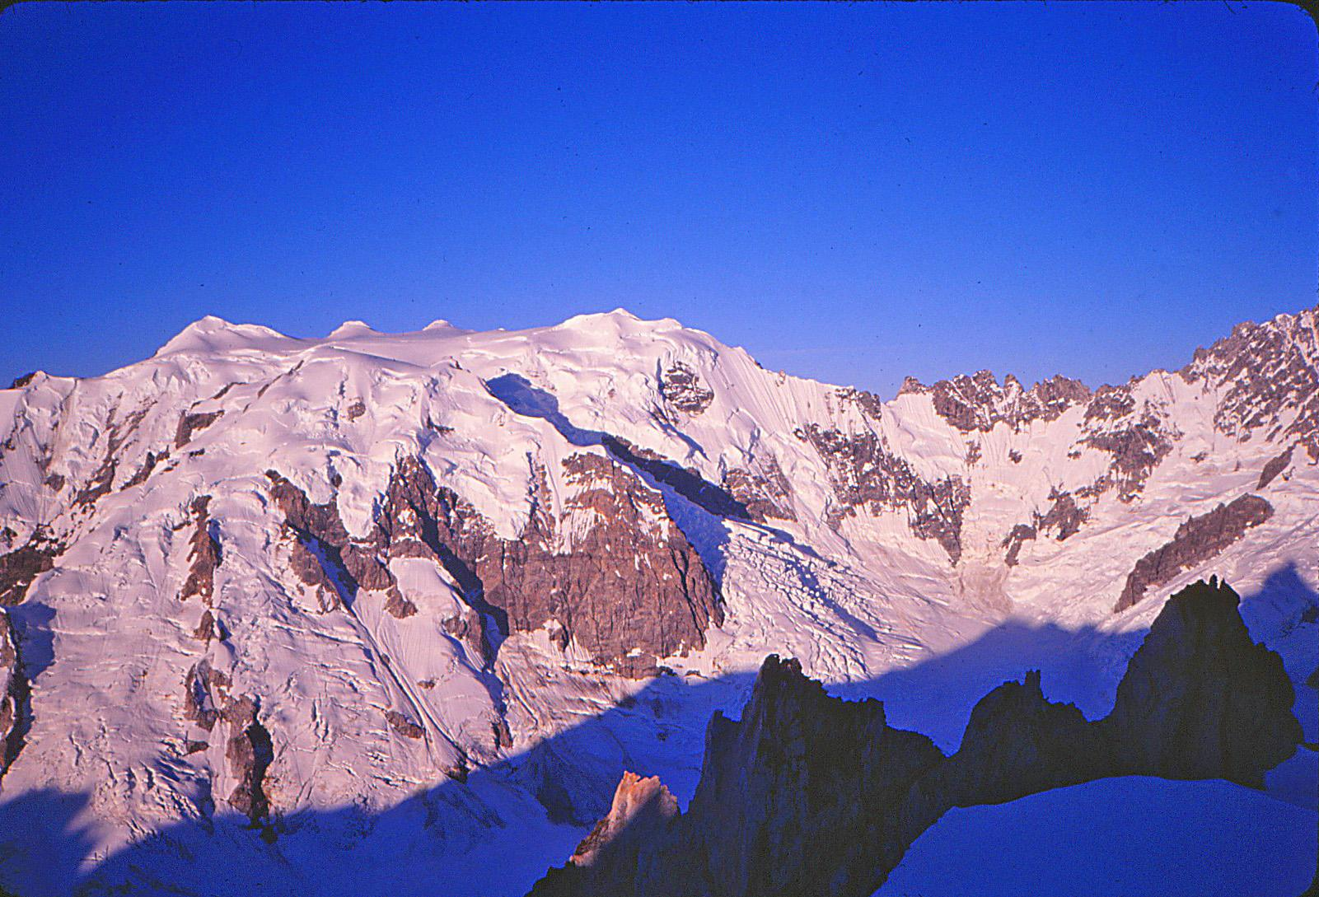

The North Face of Mt Munday, Waddington Range, British Columbia. Photo by Dave Creeden.

**Bonus Material #3: Bugaboo Spire, East Face in 1960 by Ed Cooper and Art Gran.**

This summit register is for new route up the East Face of Bugaboo Spire by Ed Cooper and Art Gran. As with most of Cooper’s climbs, there is an interesting story behind the climb, which he wrote about in his book *Soul of Heights*.

In 1959 Art Gran and Cooper got to within 700 ft of completing the route, so they planned for a return engagement in the summer of 1960. To share costs, Cooper enlisted Eric Bjornstad for the trip from Seattle to the Bugaboos in July. Art Gran would drive from New York state. While waiting for Gran to arrive, Cooper and Bjornstad climbed the North Face of Howser Peak, a new route. Time continued to pass, so Cooper made ascents with other climbers including Pigeon Spire with Layton Kor, another new route.

Then Cooper was afflicted with a bad case of food poisoning. After he recovered, Cooper started up the East Face of Bugaboo Spire in early August, alone. He completed about 65% of the route, using a self-belay system before Art Gran arrived. At this point they were confident they could complete the climb in a day, so they climbed with minimum gear (no headlamp, extra clothing, crampons or ice axe). They reached within 100 feet of the summit before darkness, as the weather deteriorated. Cooper claims this was the coldest night he ever spent on a mountain. The next morning, they reached the summit.

The summit register entry included below, was made by Cooper early in the morning.

With difficulty they completed their descend on the bullet-hard snow below the Snowpatch-Bugaboo col, by cutting steps with their piton hammers.

Cooper’s photograph of the East Face of Bugaboo Spire graces the dust cover of his book, *Soul of Heights* and is one of his favorite photographs.

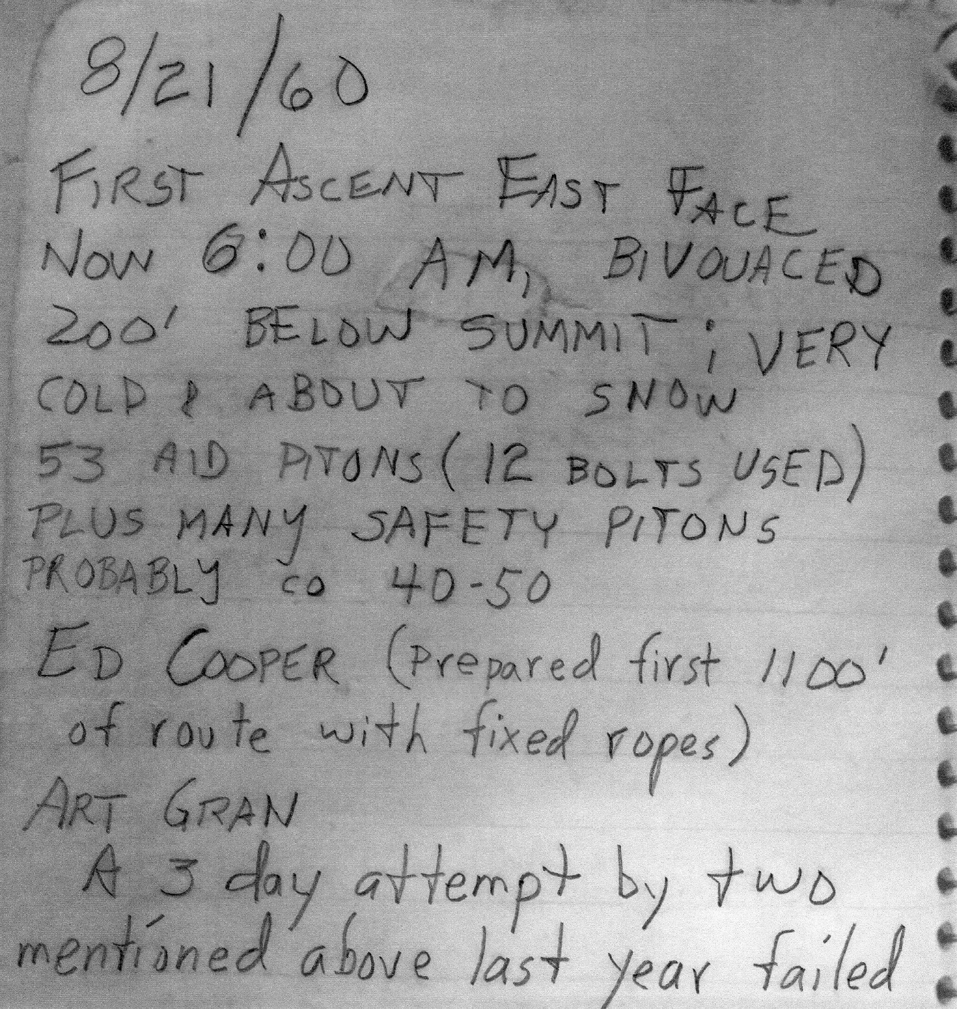

Image M235/accn 5200-20 is courtesy of the Whyte Museum of the Canadian Rockies.

Author: Dave Creeden.